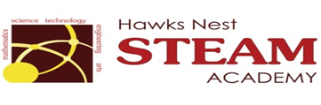School Counseling Program Newsletter
Shandrai Silva, School Counselor | February 2017

Counselor Message  Happy February! Our second half of the school year has gotten off to a great start!  In January, the school counseling program continued with classroom guidance lessons, small group counseling and individual meetings with students. We recognized No Name- Calling Week which included Student Council making classroom presentations. We also participated in the Great Kindness Challenge Week- bucket filling abounds at Hawks Nest!  The NED Show visited Hawks Nest  in January as well. We were reminded  of the importance of Never Giving Up,  Encouraging Others and Doing Our  Best.  Great things are happening at the  Nest! Stay Tuned!  _________________________  How to see the school counselor  Classroom guidance classes are weekly based on grade level specials schedule. Small group counseling and individual counseling by self -referral, parent referral, teacher referral, administrator referral or counselor initiated.  Contact School Counselor at 704-866-8467or sosilva@gaston.k12.nc.us.   | Home of the Hawks    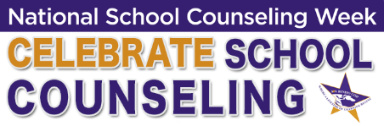  February 6- 10, 2017  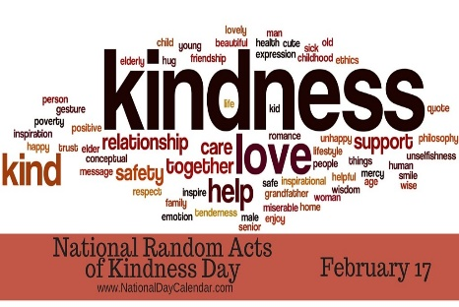  NATIONAL RANDOM ACTS OF  KINDNESS DAY – February 17    Black History Month  February 2017 | Character Education  “We’re Soaring with Good Character”  ______________________________  The character trait of the month is Self-discipline. Self-discipline means being responsible for your actions; being in charge of the things you say and do and making choices that are healthy, safe, kind and respectful to others.  __________________________________  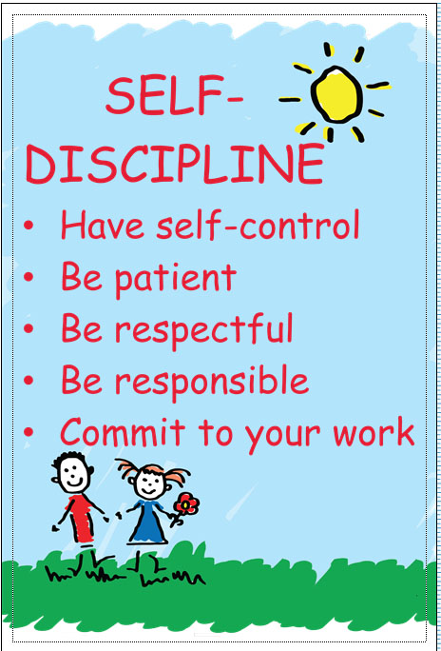  http://estherwuschoolcounselor.weebly.com/character-education.html  “Intelligence plus character- that is  the goal of true education.”  Dr. Martin L. King, Jr.    